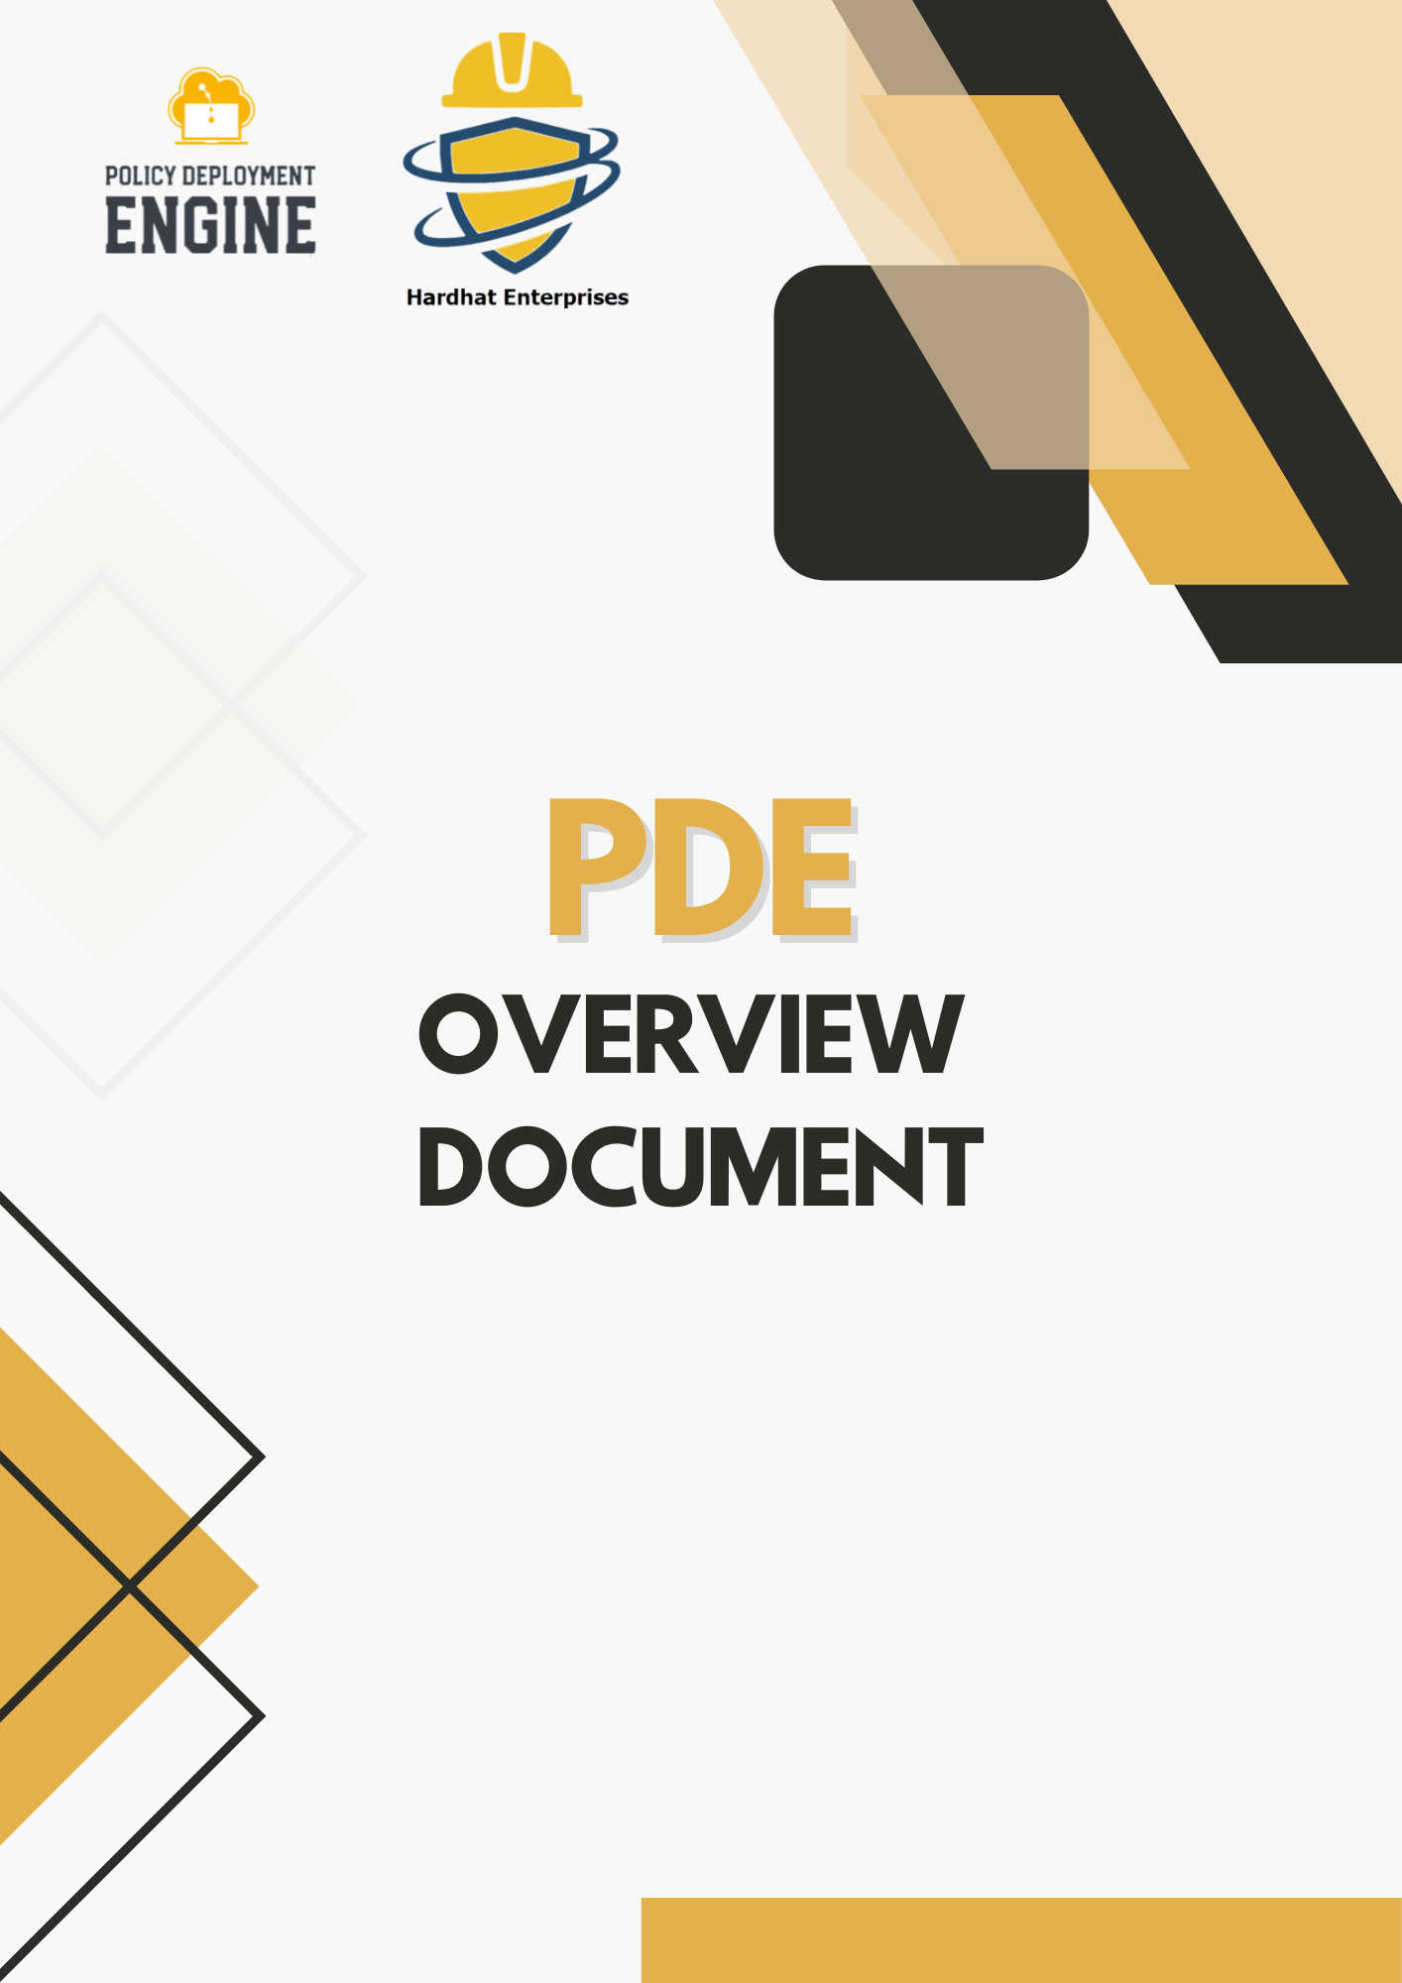

Table of Contents
❖ Overview 3
❖ Current Goals 3
❖ Tasks Completed 4
❖ Future Goals 4

Overview

The Policy Deployment Engine is designed to automate and simplify the enforcement of security policies across cloud environments, starting with Google Cloud Platform (GCP) and expanding to AWS and Azure. The project focuses on developing a centralized system to efficiently deploy, manage, and update security policies, ensuring compliance and reducing manual effort. The engine aims to enhance security, improve operational efficiency, and provide organizations with a scalable solution for managing cloud policies by creating a structured approach to policy implementation.

Current Goals

1. Establish the New Project – Set up the foundation for the Policy Deployment Engine, defining its scope, objectives, and initial structure to support cloud security automation.
2. Train the Team – Provide training on essential technologies, including Git, CI/CD pipelines, Rego Language, Open Policy Agent (OPA), Terraform, and Google Cloud Platform (GCP) Organizational Policies, ensuring all team members acquire relevant skills.
3. Develop Core Documentation – Create structured project documentation covering architecture, workflows, coding standards, and deployment processes to support collaboration and maintainability.
4. Build the Policy Collection – Start designing and implementing a library of security policies tailored for cloud environments, ensuring compliance and risk mitigation.
5. Develop the Policy Deployment Pipeline – Design and implement an automated pipeline for deploying security policies, integrating DevSecOps best practices to streamline cloud security enforcement.

Tasks Completed

Security Related
- The destination_dataset_id is important for security because it indicates the BigQuery Dataset where the results of a scheduled query or external transfer will be saved. If an attacker can figure out or change the dataset name, they might redirect data, access sensitive information, and mess up data flows.

- Encryption configuration is crucial because it ensures that data transferred through BigQuery Data Transfer is encrypted with my own key instead of Google’s default key. This way, I can manage my encryption, monitor its use, and revoke access if needed.

- The location determines where the BigQuery Data Transfer job and data processing occur. Since we are in Australia, we want to ensure that everything happens here, which is why I configured the Terraform to use Australia.

- Sensitive params are important for security because they might contain credentials or secrets that allow access to external resources, like AWS S3 buckets.

Non-Security Related
- The display_name attribute in a BigQuery Data Transfer configuration is simply a human-readable label used for identification and usability purposes in the UI or API. It does not influence access control, encryption, IAM policies, or data flow behaviour.

- The data_source_id in a Google BigQuery Data Transfer configuration is a static identifier that tells Google what type of source system the transfer is connecting to youtube_channel, google_ads, and aws_s3.

- Schedule and Schedule option are not security-related because the schedule does not affect data access, does not expose or transport sensitive data itself, and it only controls timing.

- The email preferences attribute in a BigQuery Data Transfer configuration simply controls who receives email notifications. It does not control access to data, encryption, secrets, or authentication.

- The Data Refresh window days are not security relevant because its job is to refresh data.

- Disable is not security relevant because if the disable set to true there will be no transfer schedule, no automatic schedule data pulls.

- The service account name is not security-relevant is because the service account is running internally 90% of the time. In some cases, if the service account runs externally, that will be security-related.

- Start time and end time are not security-related because start time is the time when transfer is allowed, and the end time is the cutoff point after which no new transfer will be scheduled.

Future Goals

I am planning to take on some tasks from seniors, which will be my responsibility for the upcoming semester. Currently, I am engaged in another assigned service focused on Network Security. My immediate goal is to begin documenting resources related to Network Security and to create Terraform examples that illustrate both compliant and non-compliant scenarios. These examples will serve as valuable resources for future contributors who will be working on similar projects. Additionally, I need to merge the existing document into the Mark Down format to ensure consistency and ease of access for all team members.

